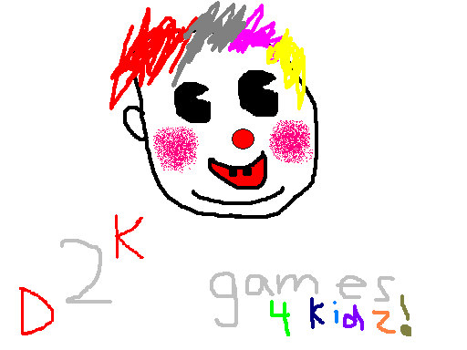
Team Contract
Team Name – _{D}2^{K} Games Studios
Leader – Jun Cho / Team representative – Calvin Chan

Team duties:
- Each team member will do their share of the work (ideally 1:1 ratio)
- Explain the work that they completed to each other
- Understand all parts of the program regardless of who coded which part
- Inform the other group members of problems encountered
- Encourage and support others when necessary

Team Leader duties:
- Be a good role model for the group
- Make sure everyone is on task
- Organize tasks
- Plan tasks

Team representative duties:
- Represent the group in a good image
- Report to the group leader
- Keep Ms. Dyke updated on any major progress in the code

Consequences for breaking the contract:
- If it is a serious breach of the contract, the person will be humiliated in front of the class.
- Person who breaks the contract owes the other person a drink of choice within reason.
- An apology letter must be submitted by the offending party to the other group member(s).

Ways to resolve conflicts:
- Peaceful discussion/meeting to resolve the conflict/problem as calmly as possible.
- Match of tetris or another game (both parties must agree to the game to play). This method is to resolve a stalemate situation where both parties think they are right.

I, __________, have taken the oath of programming and agree to all terms of this contract.

Group member 1 signature: ________________________ Date: ________________________

I, __________, have taken the oath of programming and agree to all terms of this contract.

Group member 2 signature: ________________________ Date: ________________________

